**ISCSI SERVER CONFIGURATION**

**PROJECT REPORT SUBMITTED**

**TO**

**RAJASTHAN TECHNICAL UNIVERSITTY**



**In the partial fulfillment of the requirements of**

**MASTER OF COMPUTER APPLICATION**

**Project guide: Submitted by**

**Mr. ANIL DANAKAR SURAJ YADAV Roll No : 1940714**

**MCA IV Semester**

**2019-2020 Batch**

**UNIVERSITY CENTER FOR**

**RAJASTHAN INSTITUTE OF ENGINEERING AND TECHNOLOGY, JAIPUR**

**CERTIFICATE**

This is to certify that the project reporton **‘ISCSI SERVER CONFIGURATION’(**remote block storage)is a confide record of the work done by **Mr. SURAJ YADAV** during the IVth semester and submitted in partial fulfillment of the requirement of the degrees of **Master of Computer Application** of University of Rajasthan.

**Submitted for the University exam held on** ………………….

**Dr. PANKAJ NAGAR**

**(DIRECTOR)**

**ACKNOWLEDGEMENT**

I am indebted to many people who have aided, motivate, encouraged and helped us in the development of this project. It is my pleasure to acknowledgement all those people.

First of all, I like to express our sincere gratitude to Lord God Almighty whose grace has always been here with us for the successful completion of this project.

I wish to express my deep sense of gratitude and indebtedness to Mr. ………………, Lecturer and lab guide, for their full support and valuable guidance while completing the project. I would like to thank my friends for their invaluable moral support and help throughout his project.

My specially thanks to KUSHAL SAMOTA (Linux expert)

My heartfelt thanks will always be there for my parents, my teachers for the unending supports and encouragement they have given.

**SURAJ YADAV**

**MCA IV semester**

INDEX

**iSCSI SERVER CONFIGURATION**

* Introduction
* Requirements Documents
  + Server Objective
  + Need of iSCSI server
  + Server Context
  + Functional Requirements
  + Non-Functional Requirement
  + Future Requirement
* Project Overview
* Project Scope
* Assumption and Dependencies
* Server Architecture
* iSCSI Analysis & design considerations
* General Discussion
* Performance/Cost
* High Bandwidth, bandwidth aggregation
* Coding
* Ease of implementation/complexity of protocol
* Reliability and Availability.
* Interoperability
* Internet infrastructure
* SCSI
* Security Considerations
  + Extensible Security
  + Authentication
  + Data Integrity
  + Data Privacy
* Conclusion

**Introduction**

The Internet Small Computer System Interface (iscsi) is TCP/IP based protocol emulating a SCSI high-performance local storage bus over IP networks, providing data transfer and management to remote block storage block device. As a storage area network (SAN) protocol, iscsi extends SANS across local and wide area network (LAN, WANS, and Internet), providing location-independent data storage retrieval with distributed server and arrays.

iSCSI was pioneered by IBM and Cisco in 1998 and submitted as a draft standard in March 2000.

 The architecture of iSCSI is similar to that of a client/server architecture, where an initiator acts as the client that issues an I/O request and the target (a device in the storage system) acts as a server. Distance extension can be achieved by this architecture when used over IP networks.

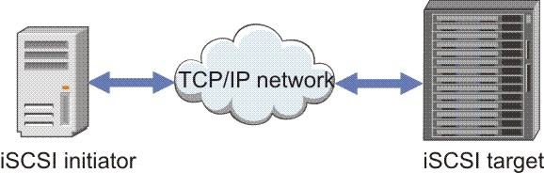

**Requirements Document**

First we are developing a Software Requirement Specification (SRS) document that specifies what a iSCSI server configuration should and should not do. The SRS document is divided into five sections namely.

* **System Objectives**
* Describe the network stack of iscsi protocol components
* Describe the topology distinctions between Fibra Channel and iscsi
* Describe the distinction between block I/O and File I/O
* **Need of iSCSI server configuration**
* iSCSI provides cheap connectivity as compared to FC.
* An existing network can be used for iSCSI implementation.
* As iSCSI is used for block storage, it is very fast.
* IT folks don’t need a lot of training on iSCSI storage since it is very easy to understand and implement.
* iSCSI is an IP-based protocol. It leverages the interoperability benefits of TCP/IP and Ethernet.

**System Context**

This section clearly depicts the environment and boundaries of the iSCSI server and the client with which it interact. It helps us see how the server fits into the existing scheme of things. What the server will do by itself and what is expects other clients to do is clearly delineated.

* **Functional Requirements**

These requirement state the function of the server – what it should do and what it should not. This will includes the most common requirement of the customer in additional feature. It also shows the server behave while it interact with the user.

* **Non-Functional Requirements**

**The non-functional requirements describe how the server works, while functional requirements describe what the system should do.**

* **Future Requirements**

iSCSI is very cost efficient and can be easily understood by any IT guy. iSCSI is a flexible protocol which can work within any environment. iSCSI does not require dedicated cabling, it can be run over existing IP infrastructure. It can be deployed on local or wide area networks through the use of Internet across distributed resources. Another reason iSCSI is widely used is because many operating systems support iSCSI configuration.

**Project Overview:-**

|  |  |
| --- | --- |
| Overview | |
| Goal | To provide and use networked iscsi block device as remote disks |
| Objective | * Explain at high level how iscsi is used to provide remote access to block devices. * Provide remote access using local risk as a LUN of an iscsi storage target * Access remote storage using an iscsi initiator and prepare it for use. |
| Sections | * iscsi concepts (and Practice) * provides iscsi target (and Practice) * Accessing iscsi Storage (and Practice) |
| Lab | Providing block-based storage |

**Project Scope:-**

Now a days, iscsi server is very important and hence it is necessary for every client who are not capable to attach a physical hard disk or storage device with system because they want to less everything and request to server to provide remotely to TCP/IP internet environment.

A **storage area network** (**SAN**) or **storage network** is a [Computer network](https://en.wikipedia.org/wiki/Computer_network) which provides access to consolidated, [block-level data storage](https://en.wikipedia.org/wiki/Block_device).

**Assumption and Dependencies:-**

* It reduce the traffic.
* It provide plateform independent configuration.
* It provide remote block storage.
* It provide remote hard disk and disk image file.
* It can provide static or dynamic hard disk.
* Server receive an chargable amount for giving service to client.

**Server Architecture**

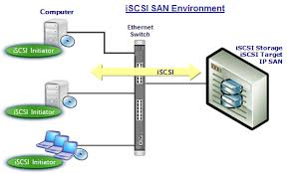

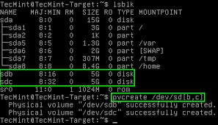

iSCSI Analysis & Design

* General Discussion
* The iSCSI standard MUST specify how SCSI devices interact when attached to IP
* networks.
* The iSCSI standard MUST use TCP as its transport.
* The iSCSI standard MUST not require modification to the current IP and Ethernet
* infrastructure to support storage traffic.
* **Performance/Cost**
* The iSCSI standard MUST allow implementations to equal or improve on the current
* MUST provide low delay communications
* MUST be possible to build I/O adapters that handle the entire SCSI task.
* MUST permit zero-copy memory architectures.
* MUST not impose complex operations on host software.
* MUST be cost competitive with alternative storage networking technologies.
* **high bandwidth and bandwidth aggregation**
* MUST provide high bandwidth and bandwidth aggregation.
* iSCSI initiator SHOULD be able to send simultaneously to multiple.
* interfaces on the target through multiple paths through the network.
* iSCSI standard MUST operate over a single TCP connection.
* iSCSI standard MAY specify connection binding.
* initiators and targets MAY implement connection binding.
* **Coding section**

In coding consider all parts

|  |  |
| --- | --- |
| Term | Description |
| initiator | An iscsi client, typically available as software but also implementation as iscsi HBAs. Initiator must be given unique names (see IQN). |
| Target | An iscsi storage resource, configured for connection form as iscsi server. Target must be given unique names (see IQN). A target provides one or more numbered block devices called logical units (see LUN). An iscsi can provide many targets concurrently. |
| ACL | An Access Control List (entry), an acces restricted using the node IQN (commonly the iscsi initiator Name) to validate access permission for an initiator. |
| Discovery | Querying is a target server to list configured targets. Targets use require an additional access steps (see login) |
| IQN | An iscsi qualified Name, a worldwide unique name used to identify both initiator and targets, in the mandated format:  iqn.YYYY-MM-com.revised.domain[:optional_string]  iqn-Signifying that this name will use a domain as its identifier. YYYY-MM-The first month in which the domain name of the organization creating this iscsi name.  opotional_string-An optional, colon-perfixed string assigned by the domain owner as desire while remaing worldwide unique. It may include colons to separate organization boundaries. |
| Login | Aunthenticate to target or LUN to begin client block deivce use |
| LUN | A logical Unit Number, numbered block deivces attached to and available through a target. One or more LUNs may be attached to a single target, although typically a target provides only one LUN. |
| Node | Any iscsi initiator or iscsi target, identified by its IQN. |
| Portal | An IP address and port on a target or initiator used to establish connections. Some iscsi implementation use portal and node interchangeably. |
| TPG | Target Portal Group, the set of interface IP addresses and TCP ports to which a specific iscsi target will listen. Target configuration (e.g., ACLs) can be added to the coordinate setting for multiple LUNs. |

* **Implementation**
* SHOULD keep the protocol simple.
* SHOULD minimize optional features.
* SHOULD negotiate optional features at session setup.
* **Reliability and Availability.**
  + SHOULD specify mechanisms to recover in a timely fashion from failures on the initiator, target, or connecting infrastructure.
  + MUST provide the ability to er from a failed, hung, or timed-out TCP
  + connection, without the loss of the session between the initiator and target.
  + This recovery MUST particularly work for non-idempotent requests
* **Interoperability**
* **Internet infrastructure**
* MUST be compatible with both IPv4 and IPv6.
* use TCP connections conservatively, keeping in mind there may be many other users of TCP on a given machine.
* SCSI
  + - SHOULD comply with the requirements of the SCSI Architecture Model
    - SHOULD track changes to SCSI and the SCSI Architecture Model
    - MUST reliably transport SCSI commands from the initiator to the target.
    - iSCSI MUST support FIFO delivery of SCSI commands from the initiator to the
    - target, to support SCSI Task Queuing.
* **Security Considerations**
  1. **Extensible Security**
     1. SHOULD require minimal configuration and overhead in the insecure operation.
     2. SHOULD allow integration of new security mechanisms without breaking backwards
  2. **Authentication**
     1. MAY support various levels of authentication security.
     2. The iSCSI protocol MUST support private authenticated login.
     3. iSCSI authenticated login MUST be resilient against passive attacks.
  3. **Data Integrity** 
     1. should NOT preclude use of additional data integrity protection protocols (IPSec, TLS).

ii.MUST support the negotiation of a data integrity check format for use in CRC generation

iii.SHOULD use separate CRCs for data and headers.

* 1. **Data Privacy**

1. MAY use a data encryption protocol such as TLS or IPsec ESP to provide data

privacy between iSCSI endpoints.

**Providing iscsi Targets**

**Objectives**

* Prepare a Red Hat Enterprise Linux server to provide the iscsi target service.
* Build iscsci target and LUNs for network access.
* Limit access to iscsi targets and LUNs.

**iscsi target overview**

In original SCSI protocol terminology, a target is a single connectible storage or output device uniquely identified on a SCSI bus. In iscsi, in which the SCSI bus is emulated across an IP network, a target can be a dedicated physical device in a network-attached storage enclosure or an iscsi software-configuration logical device on a networked storage server. A target, like HBAs and initiators, is a n end point in iscsi bus communication, passing command descriptor blocks(CDB) to request or provide storage transactions.

To provide access to the storage or output device, a target is configured with one or more logical unit number(LUNs). In iscsi, LUNs appear as the target’s sequentially numbered disk drivers, although target typically have only one LUN. An initiator performs SCSI negotiation with a target to establish a connection to the LUN. The LUN responds as an emulated SCSI disk block device, which can be used in raw form or formatted with a client supported system.

iSCSI provides for LUN masking by using ACLs to restrict LUN accessibility to specific initiators. Except when shared access is intended. ACLs can ensure that only a designated client node can login to a specific target. On the target server,ACLs can be set at the TPG level to secure groups of LUNs, or set individually per LUN.

**iSCSI TARGET CONFIGURATION**

“targetcli” is both a command-line utility and an interactive shell in which to create,delete and configure iSCSI target components.

**STEPS OF iSCSI TARGET:-**

1. **Check the disk partition by using “lsblk” command.**

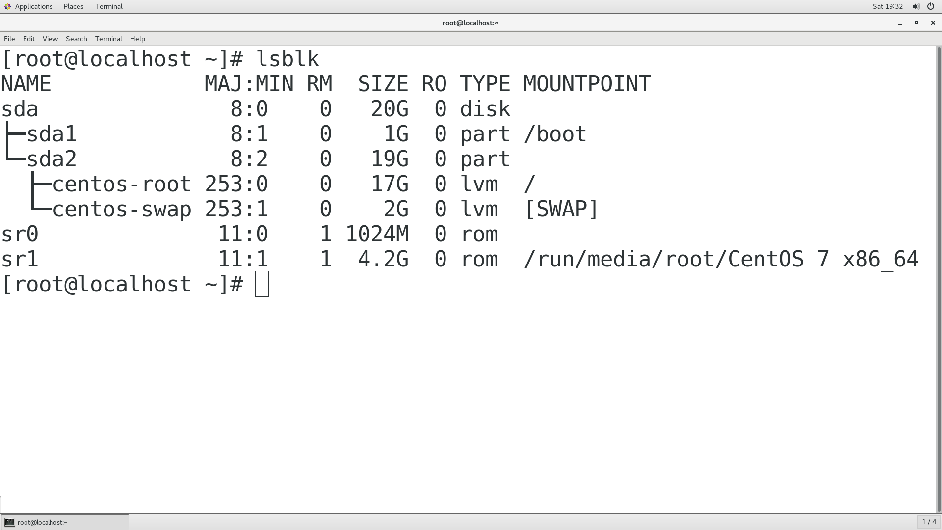

1. **Mount the CD on the other directory “/mnt/data” for configure YUM repository.**

[root@localhost ~]# mkdir /mnt/data

[root@localhost ~]# vim /etc/fstab

Entry in the fstab file of /dev/sr1

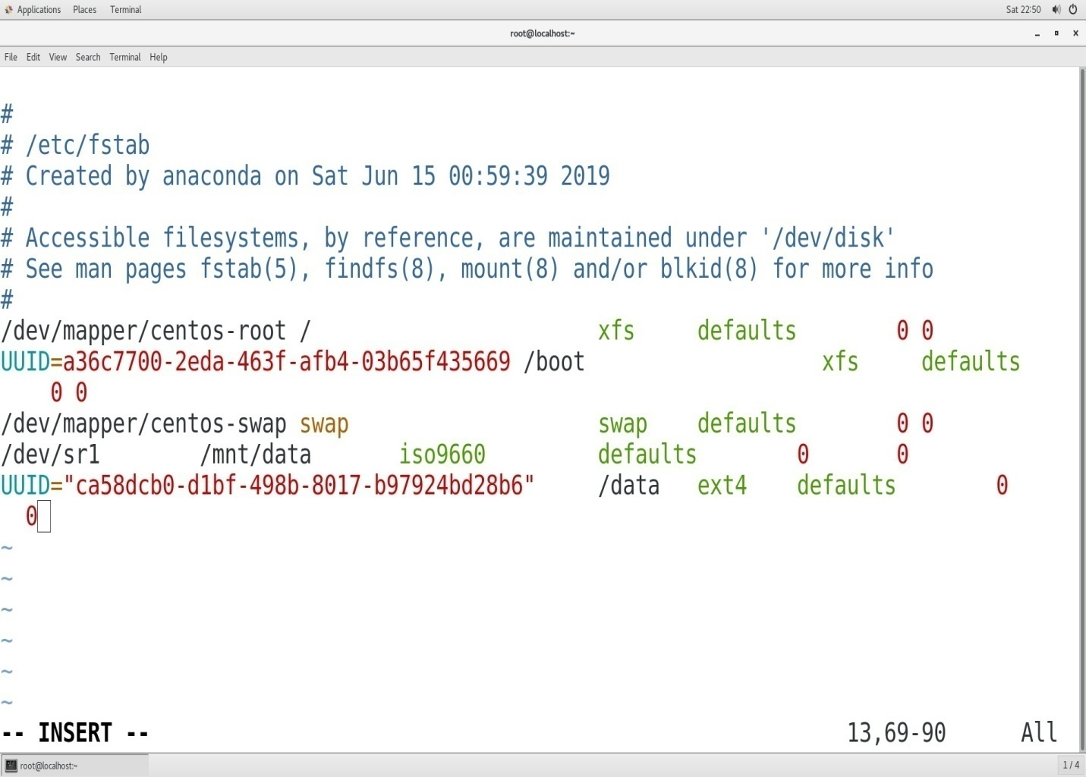

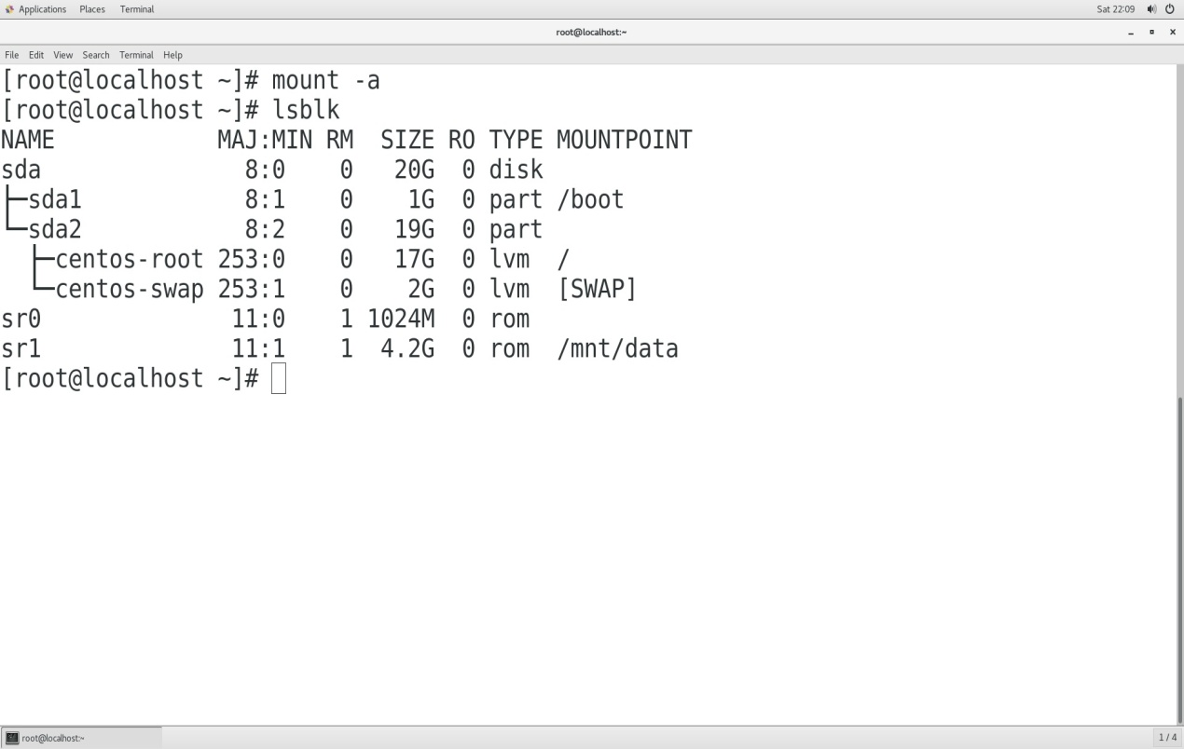

1. **Server admin add Three new new hard disk.**

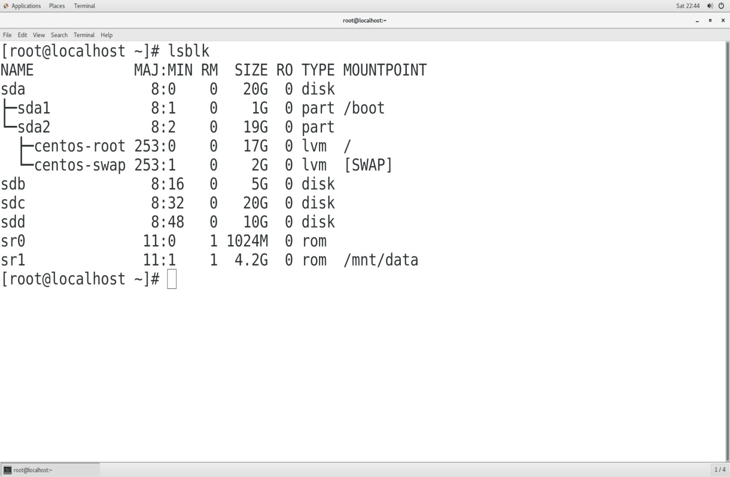

1. **Logical Volume Manager(LVM) Configuration**

[root@localhost ~]# fdisk /dev/sdc //2GB

[root@localhost ~]# pvcreate /dev/sdc

[root@localhost ~]# vgcreate vg /dev/sdc

[root@localhost ~]# lvcreate –L 2G –n lv /dev/vg

Lvcretaed succuessfully

Foramated lvm by using this command

[root@localhost ~]# mkfs.ext3 /dev/vg/lv

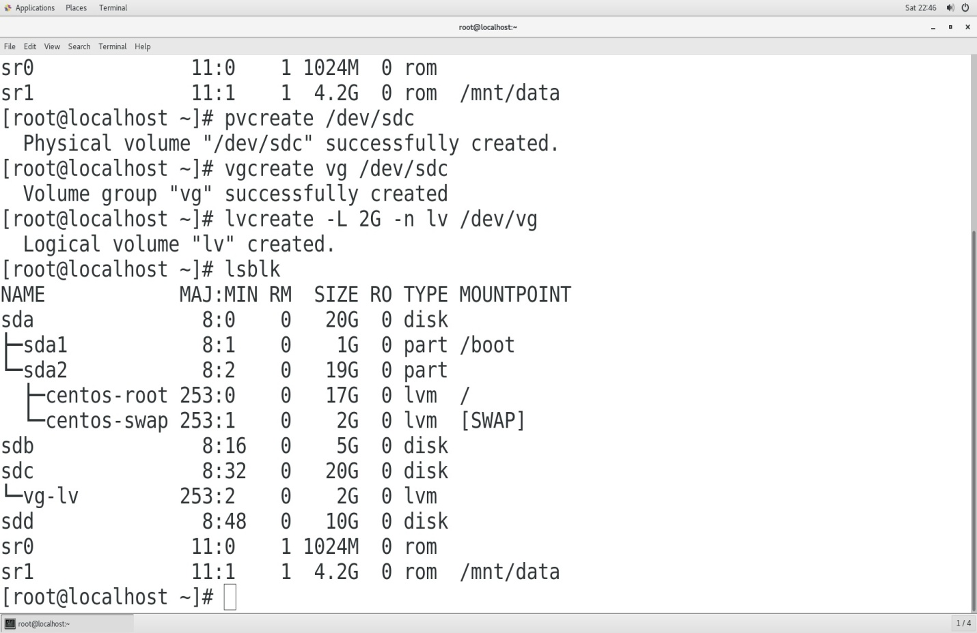

1. **Configure YUM repository**

[root@localhost ~]# yum clean all

[root@localhost ~]# yum repolist all

All package are enable with this command.

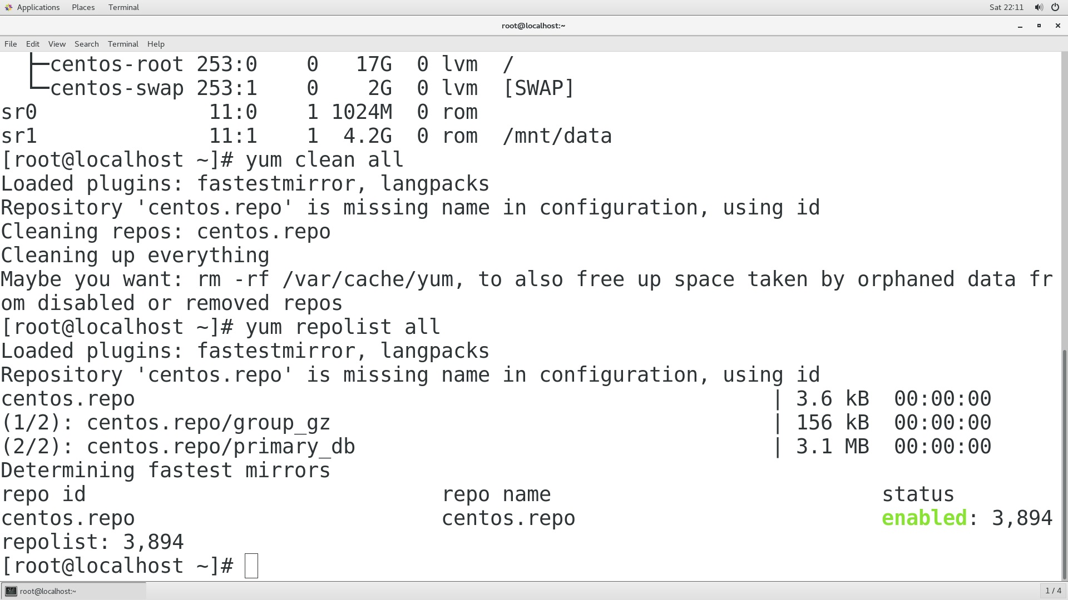

1. **Install targetcli package**

[root@localhost ~]# yum install –y targetcli*

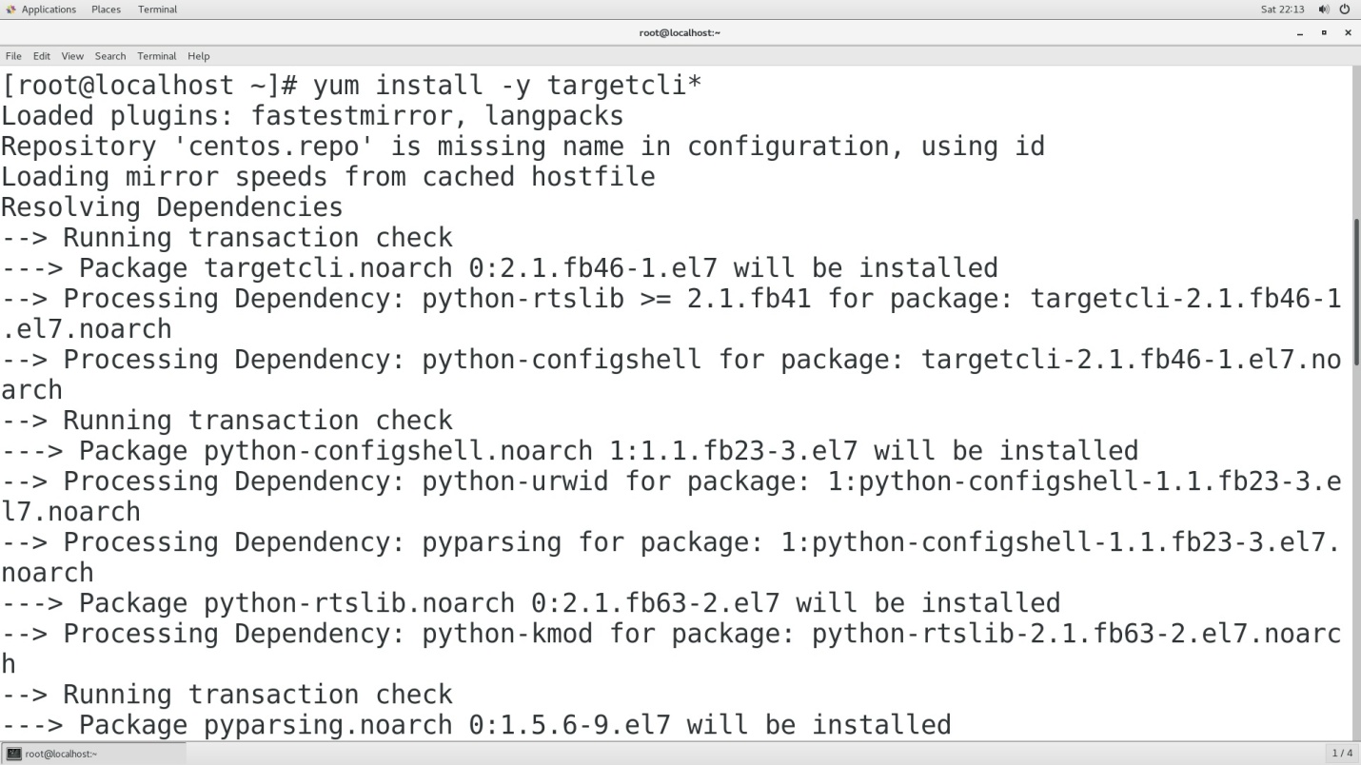

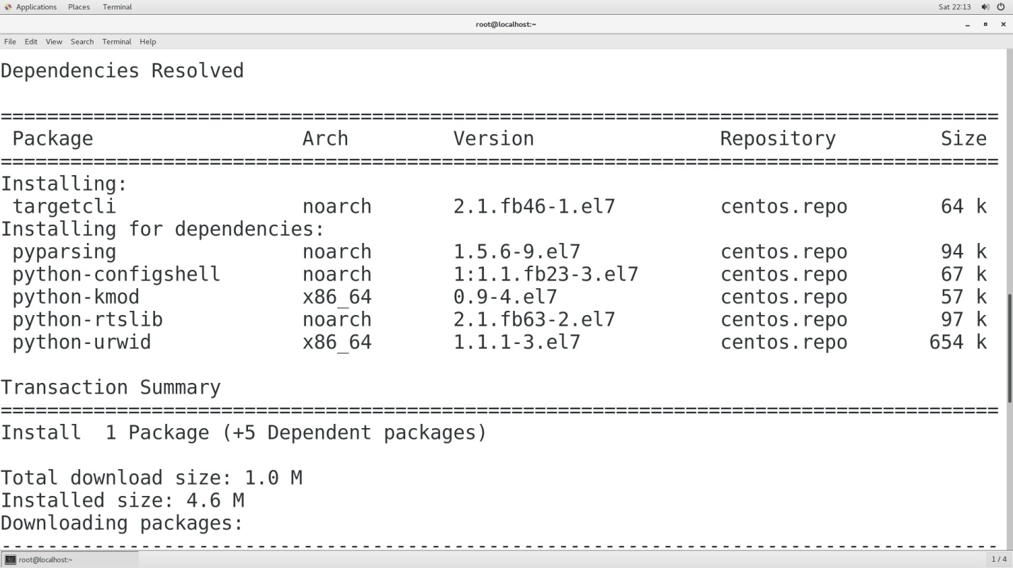

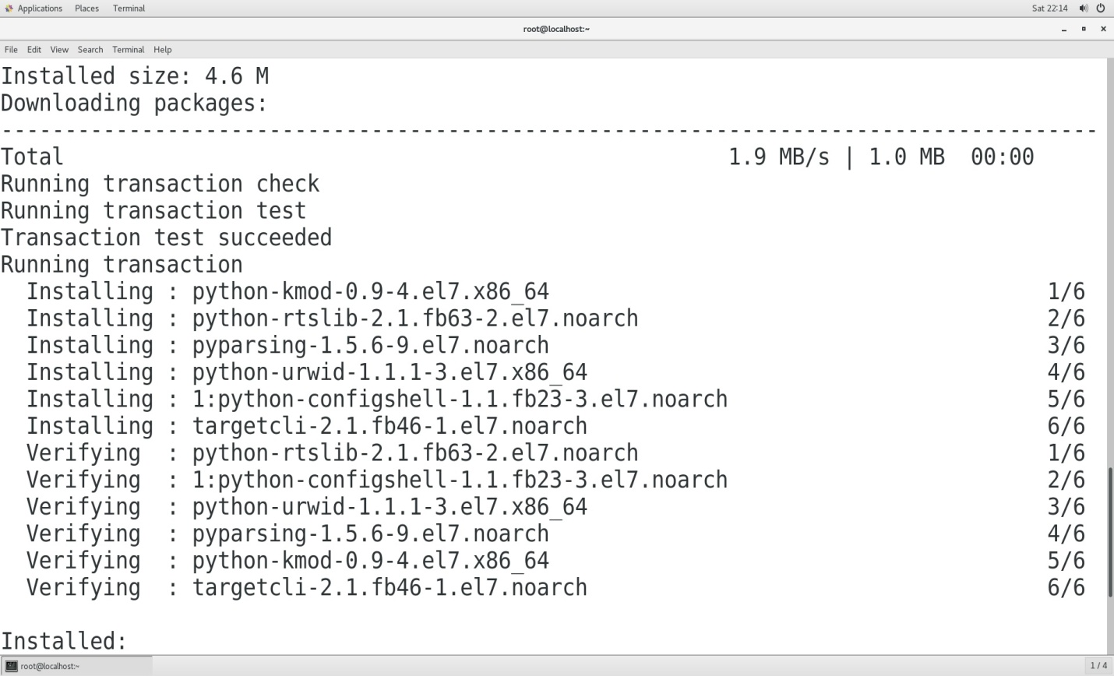

1. Add iSCSI server port and start target service

[root@localhost ~]#firewall-cmd --permanent --add-port=3260/tcp

[root@localhost ~]# firewall-cmd --reload

[root@localhost ~]# systemctl start target

[root@localhost ~]# systemctl enable target

1. Run targetcli with no option to enter interactive mode

[root@localhost ~]# targetcli

[root@localhost ~]# ls

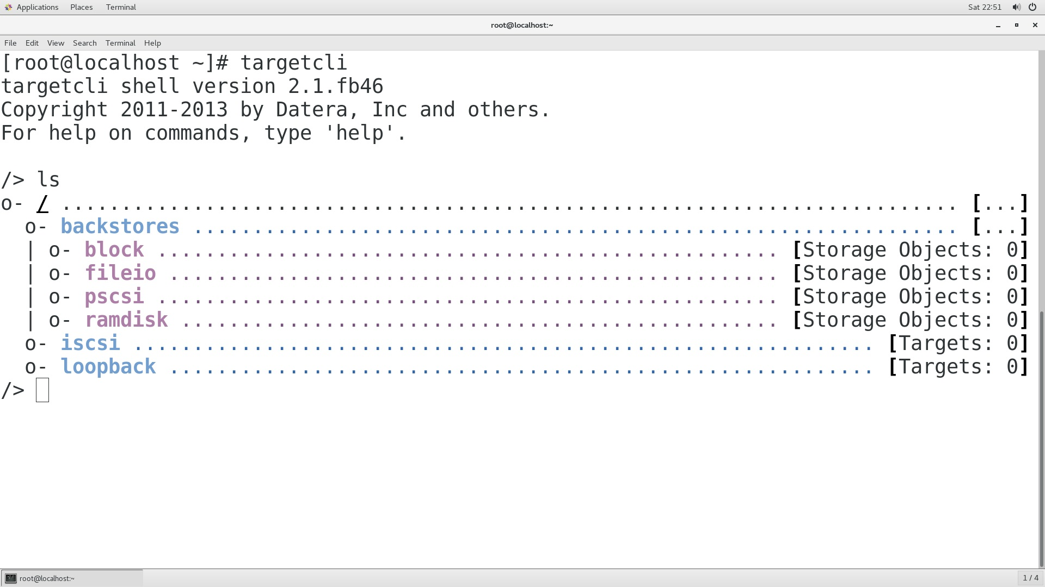

1. **Creating backing storage(backstore). There are several type of backing storage.**

* Block
* Fileio
* Pscsi
* Ramdisk

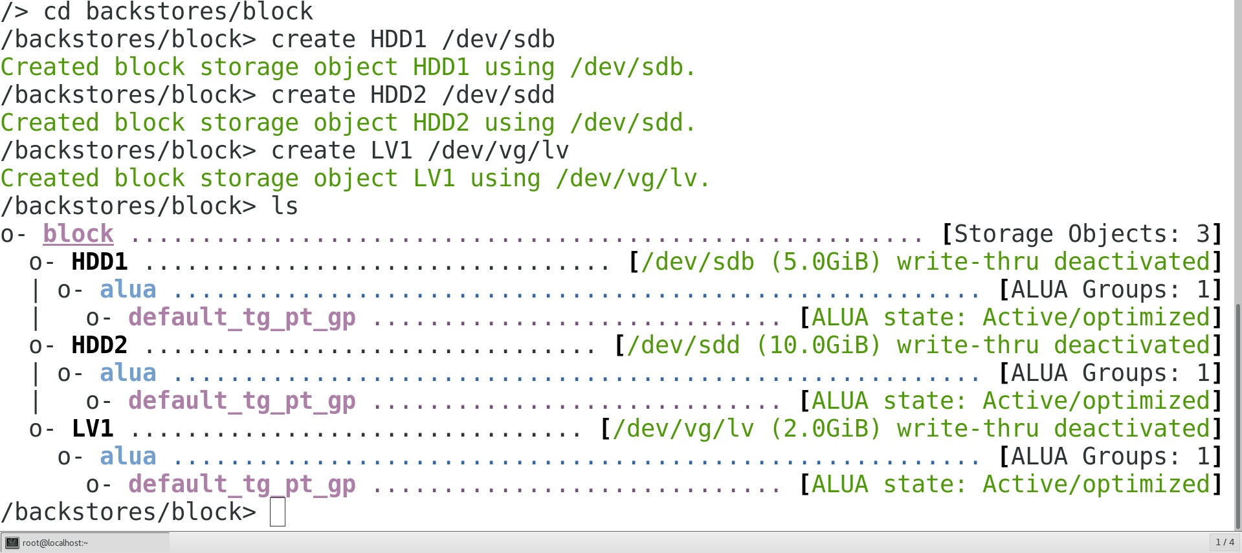

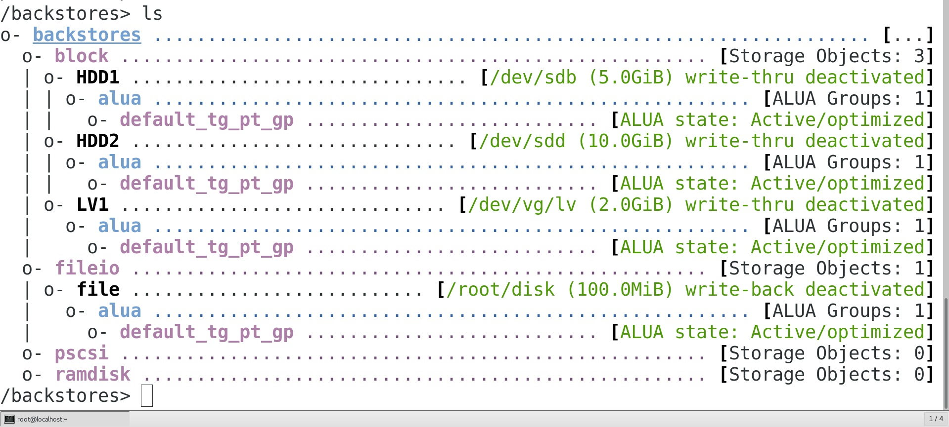

1. **Create an IQN for the target. This step will also create a default TPG underneath the IQN.**

Inaide targetcli:-

>ls

>cd iscsi

An administrator create an IQN which points to the server address, specifying the IQN value provides the ability for an administator to use meaningful namespace for their IQNs.

>create iqn.2018-04.com.example:target //server IQN

In the TPG, create an ACL for the client node to be used later,Because the global auto_add_mapped_luns parameter is set to true(defaults), any exisiting LUNs in the TPG are mapped to each ACL as it is created.

>cd iqn.2018-04.com.example:target

>cd tpg1/acl

This ACL configure to only accept initiator coonection from a client presenting iqn.2018-05.com.example:client1 as it’s initiator IQN, also known as the initiator name.

> create iqn.2018-05.com.example:client1 //client IQN

In this TPG, create a LUN for each exisiting backstore. This step also activates each backstore. Because acls exits for the TPG, they will be automatically assigned to each LUN created.

>cd ../Lun

>create /backstores/block/HDD

Having one LUNs assigned to a target means that when the initiator connects to the target, it will receive one new SCSI devices.

Still inside the TPG, create a portal configuration to designate the listening IP address and ports. Create a portal using the system’s public network interface. Without specifing a TCP port to use, the portal creation will default to the standard iSCSI port(3260).

>cd ../portals

>create ip_address=192.168.38.149 ip_port=3260

If the IP is not specified with the portal connection, an IP of 0.0.0.0 will be used. This will permit connections on all network interfaces defined on the server.

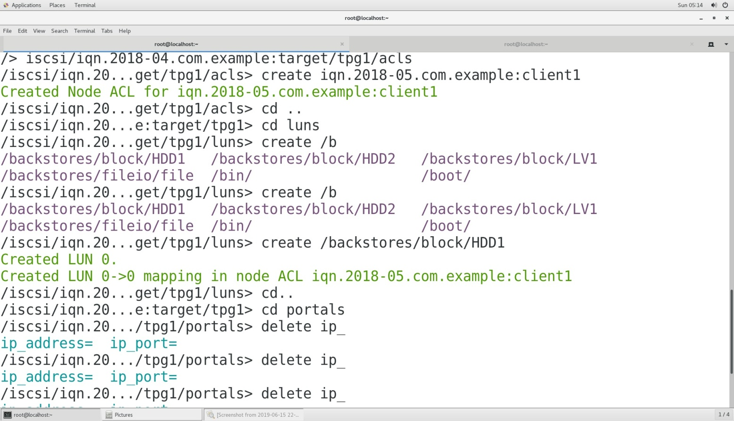

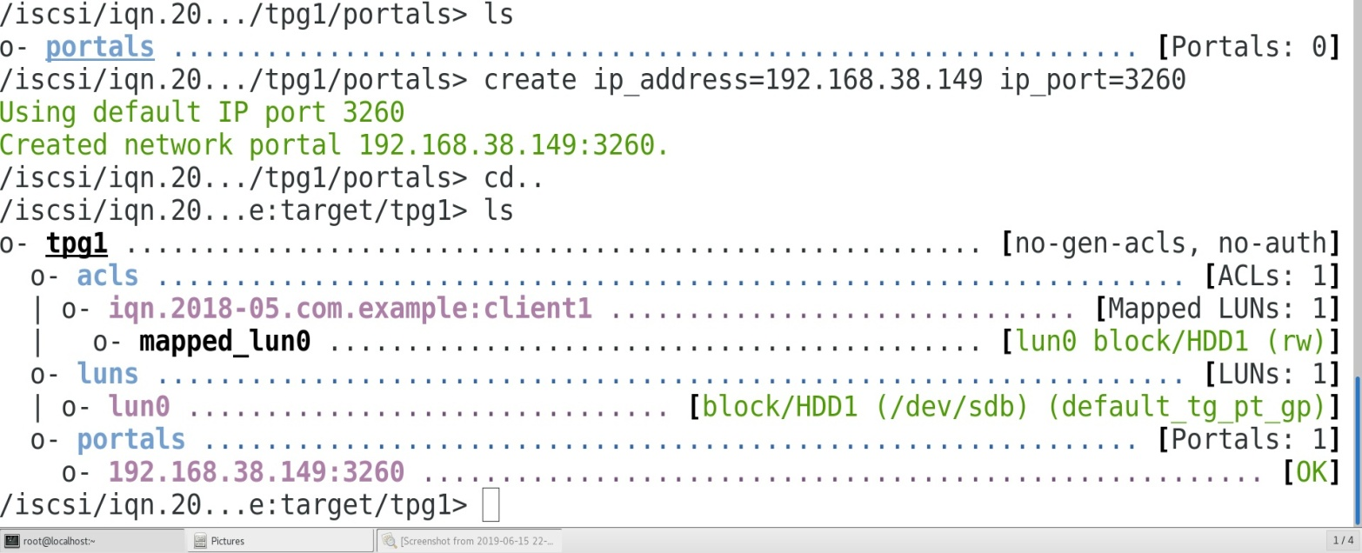

1. View the entire configuration, then exit targetcli. Targetcli will automatically save upon exit. The resulting persistent configuration file is stored in JavaScript Object Notation(JSON) format.

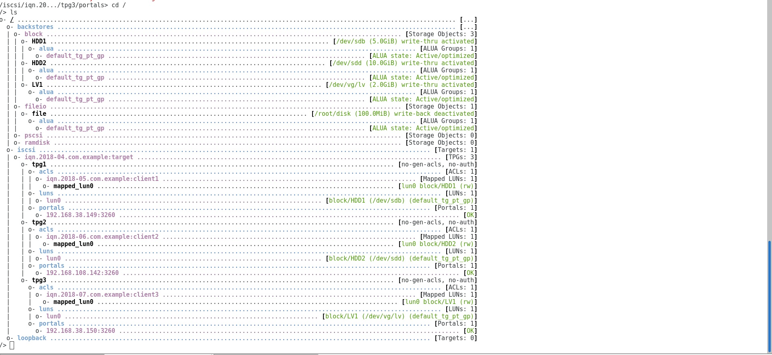

**Accessing iSCSI Storage**

**Objectives**

* Preapre a Red Hat Enterprise Linux client to access an iSCSI target service
* Access and log into a remote iSCSI portal,target and LUN.
* Practice iSCSI persistence through the use and deletion of persistence node records.

**iSCSI initiator introduction**

In Red Hat Enterprise Linux an iSCSI initiator is typically implemented in software, and function similar to a hardware iSCSI HBA to access targets from a remote storage server. Using a software-based iSCSI initiator requires connecting to an existing Ethernet network of sufficient bandwidth to carry the expected storage traffic.

iSCSI can also be implemented using a hardware initiator that include the required protocol in a dedicated host bus adapter. iSCSI HBAs and TCP offload engine (TOE), which include the TCP network stack on an Ethernet NIC, move the processing of iSCSI or TCP overhead and Ethernet interrupts to hardware, easing the load on system CPUs.

Configuring an iSCSI client initiator requires connecting to an existing Ethernet network of sufficient bandwidth to carry the expected storage traffic.

Configuring an iSCSI client initiator requires the iscsi-initiator-utils package, which includes the iSCSI and iscsid service and the /etc/iscsid./iscsid.conf and /etc/iscsi/initiatorname.iscsi configuration files.

**Steps in iSCSI initiator :-**

1. **Chceck the disk partition and available disk using “lsblk” command.**

[root@localhost ~]# lsblk



1. **Mount the CD on the other directory “/mnt/data” for configure YUM repository.**

[root@localhost ~]# mkdir /mnt/file

[root@localhost ~]# vim /etc/fstab

Entry in the fstab file of /dev/sr1

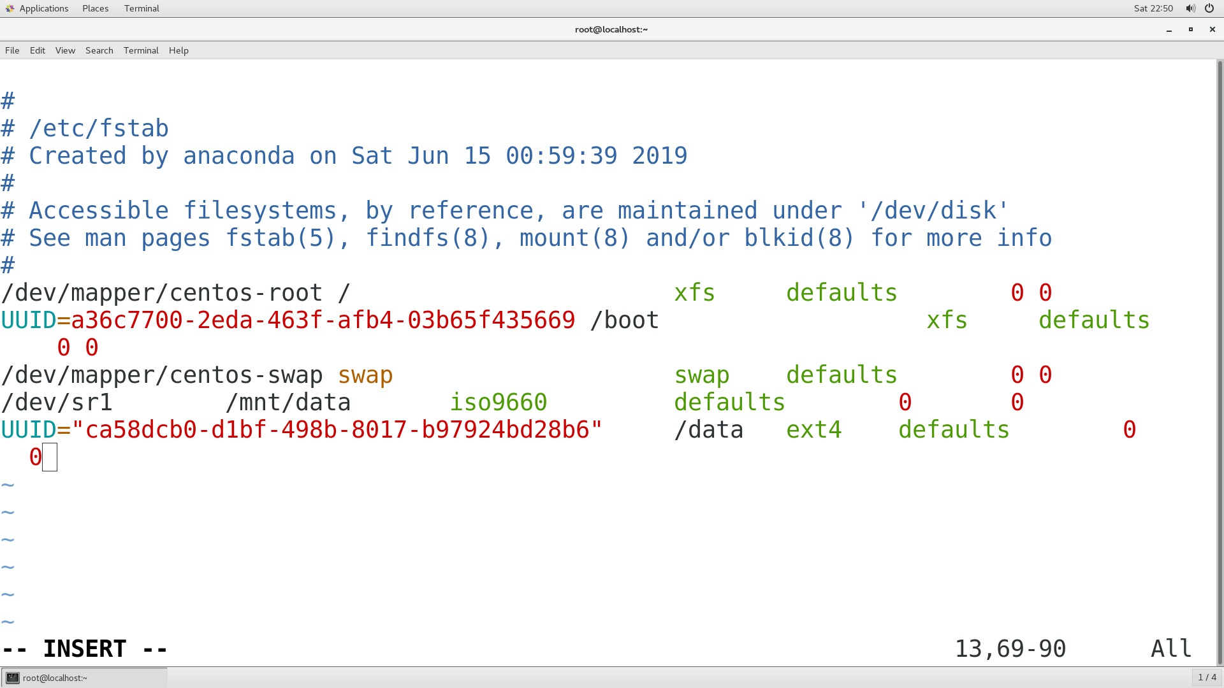

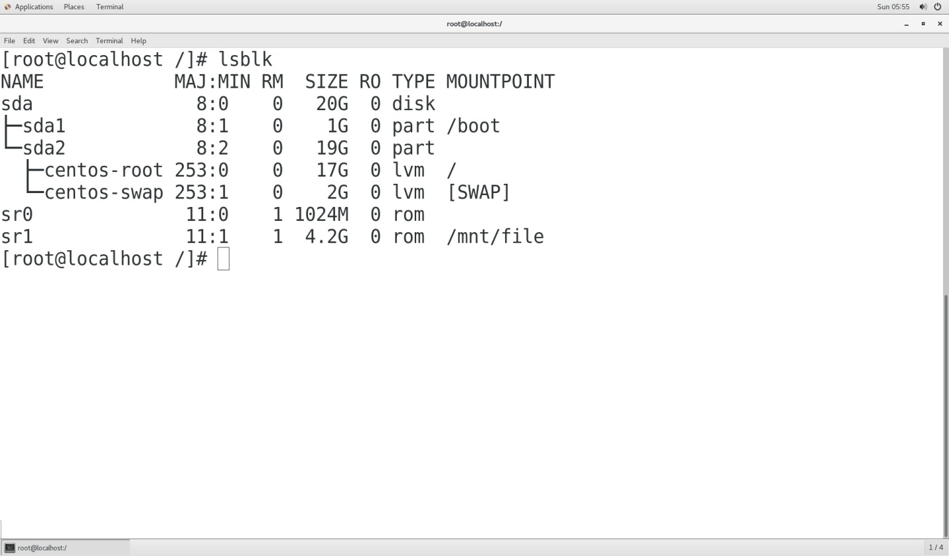

1. **Configure YUM repository**

[root@localhost ~]# vim /etc/yum.repos.d/centos.repo

[root@localhost ~]# yum clean all

[root@localhost ~]# yum repolist all

All package are enable with this command.

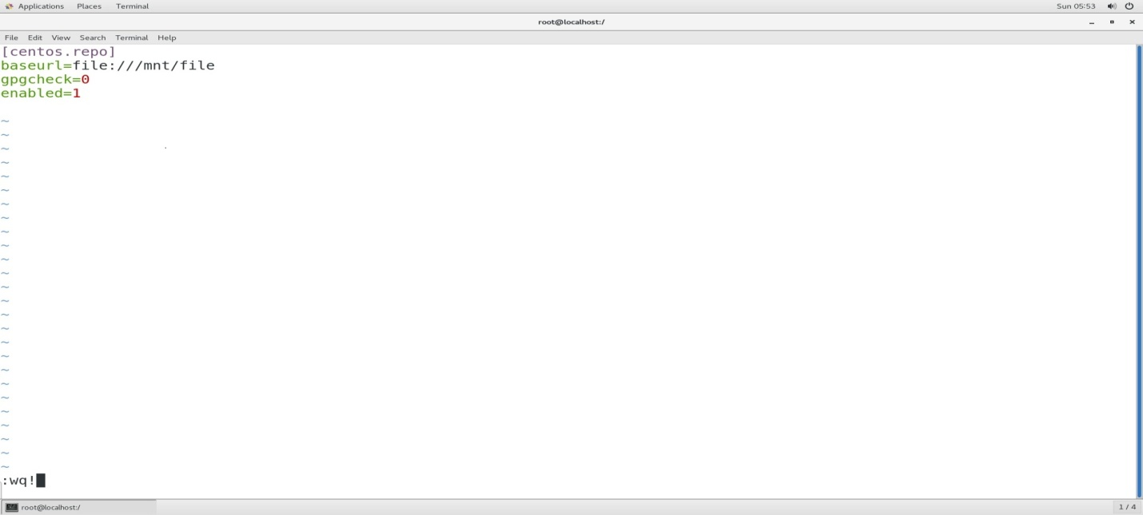



**4. Install the iscsi-inititator package**

**[**root@localhost ~]# yum install –y iscsi*

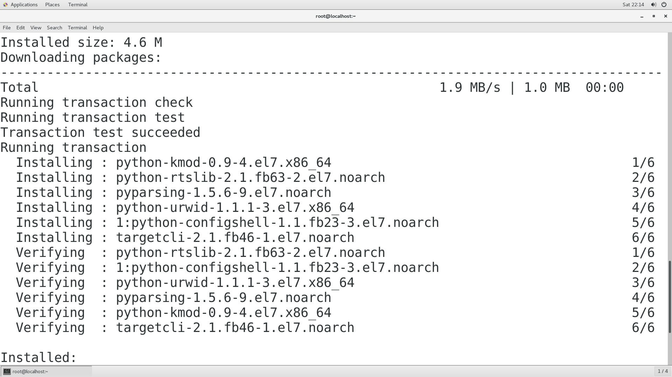

5. **Start and enable the iscsid service**

[root@localhost ~]# systemctl start iscsi

[root@localhost ~]# systemctl enable iscsi

[root@localhost ~]# systemctl start iscsid

[root@localhost ~]# systemctl enable iscsi

6. **Configure the client file**

1. /etc/iscsi/iscsid.conf file contains default setting for node records created during new target discovery. Setting include iSCSI timeouts, retry parameters, and authentication username and password. Changing this file requires restarting the iSCSI service.
2. **/**etc/iscsi/initiatorname.conf file contains a generated IQN usind Red Hat’s domain. Administrators typically reset the IQN to their own domain and an appropriate client system string.

[root@localhost ~]# /etc/iscsi/initiatorname/conf

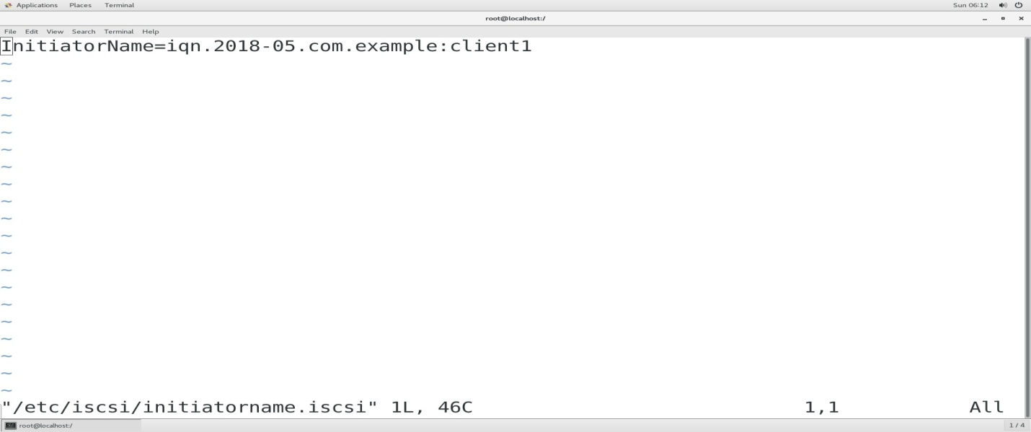

7. **Ping with server IP_Address**

[root@localhost ~]# ping 192.168.38.149

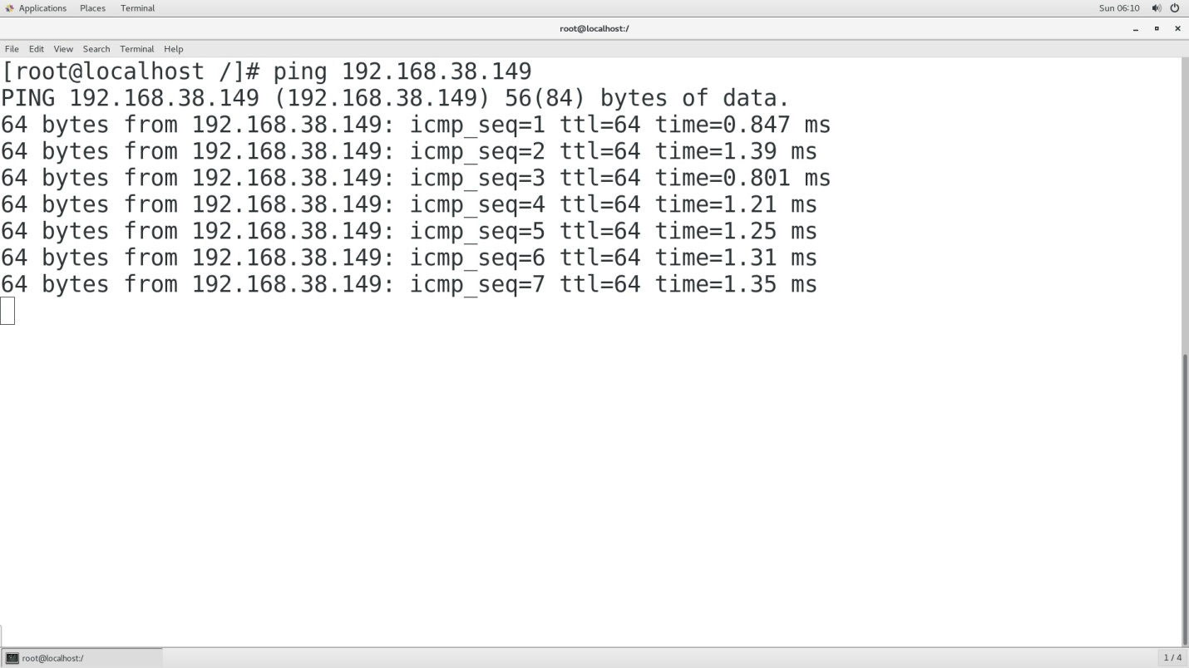

8 . **Discover the target using these command**

[root@localhost ~]# iscsisadm –m discovery –t sendtargets –p 192.168.38.149

9. **Login with finding IQN**

[root@localhost~]# iscsiadm –m node –T iqn.2018-04.com.example:target –p 192.168.38.149:3260 --login

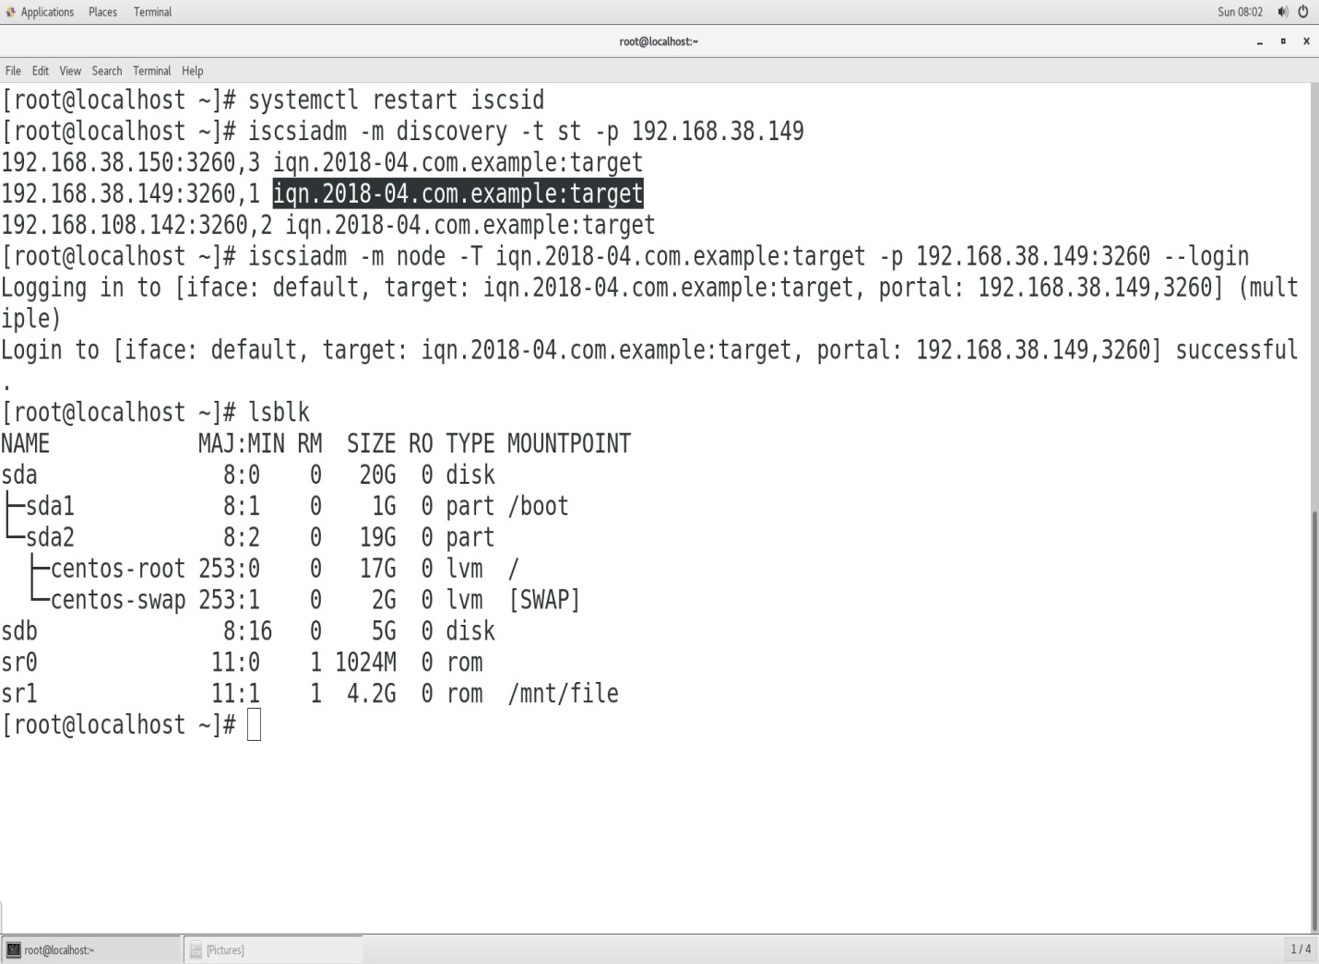

10. **Client logout securely usind these command**

[root@localhost ~]# iscsiadm –m node –T iqn.2018-04.com.example:target –p 192.168.38.149:3260 –logout

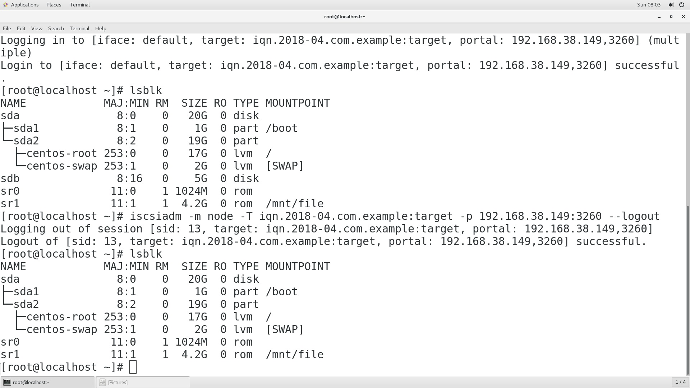

If the client request dynamic disk with server and able to do Extend demand with server.

Here the server using logical volume concept to provide desirable service to the user.

**Steps to share LVM block between client and server**

1. Server create a LUN of LVM block on the server side and share this with client



1. **Server start the target service**

[root@localhost ~]# systemctl restart target

1. **Client check disk partition by using “lsblk” command**

[root@localhost ~]# lsblk



1. **Entry perform on the iscsi-inititator file**

[root@localhost ~]#vim /etc/iscsi/inititator.conf

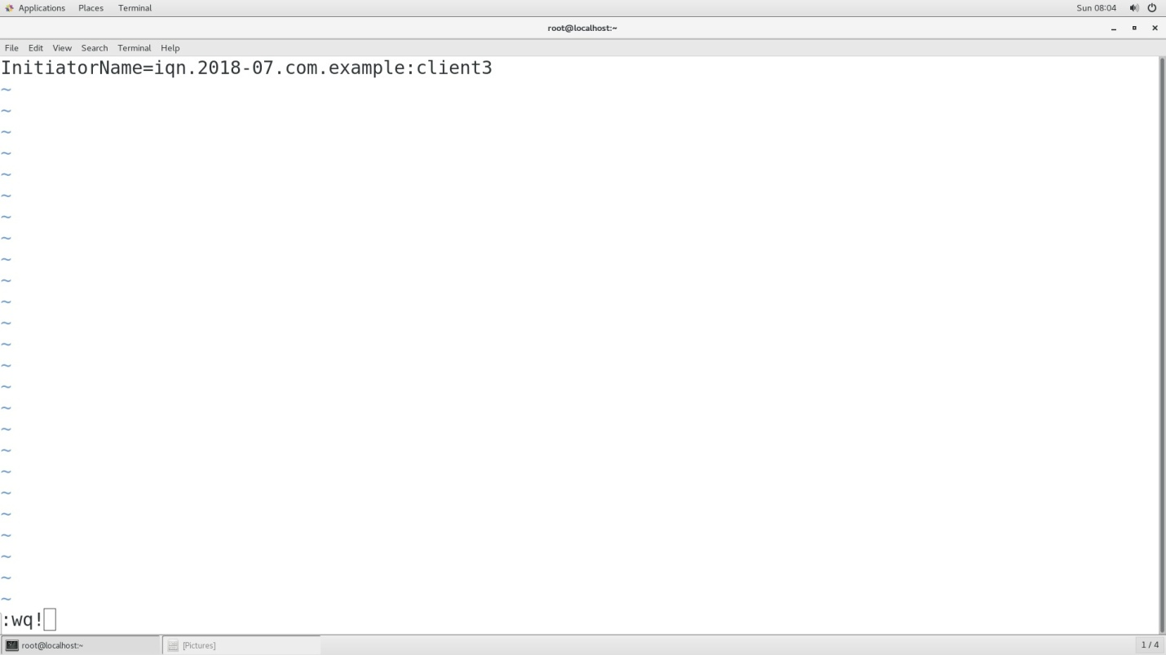

1. **Start the iscsi service at the client side**

[root@localhost ~]# systemctl restart iscsi

[root@localhost ~]# systemctl restart iscsid

1. **Ping with the server IP address**

[root@localhost ~]# ping 192.168.38.150

1. **Client discover the server IQN and login with**

**IQN and IP address**

[root@localhost ~]# iscsisadm –m discovery –t sendtargets –p 192.168.38.150

[root@localhost~]# iscsiadm –m node –T iqn.2018-04.com.example:target –p 192.168.38.150:3260 –login

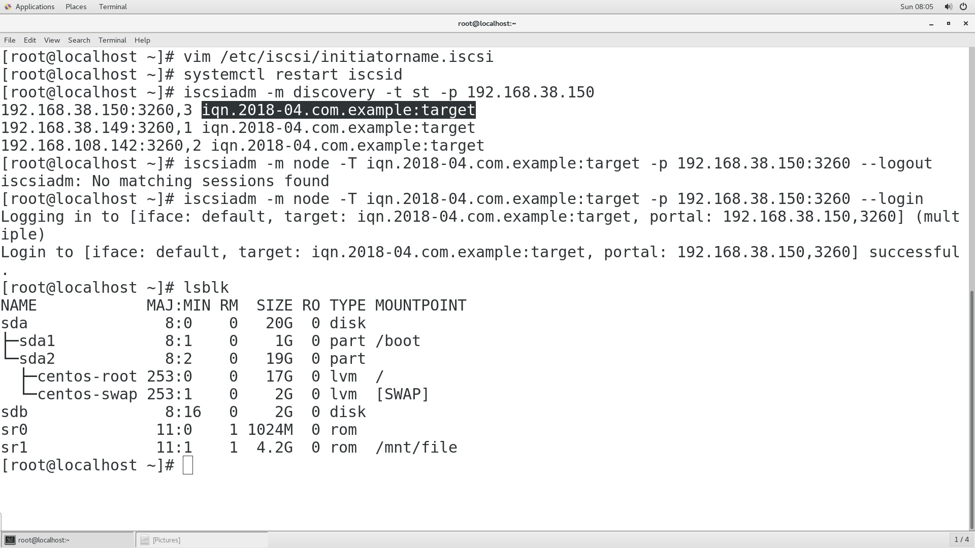

1. **Client securely logout the seesion by using these command**

[root@localhost ~]# iscsiadm –m node –T iqn.2018-04.com.target –p 192.168.38.150:3260 –logout

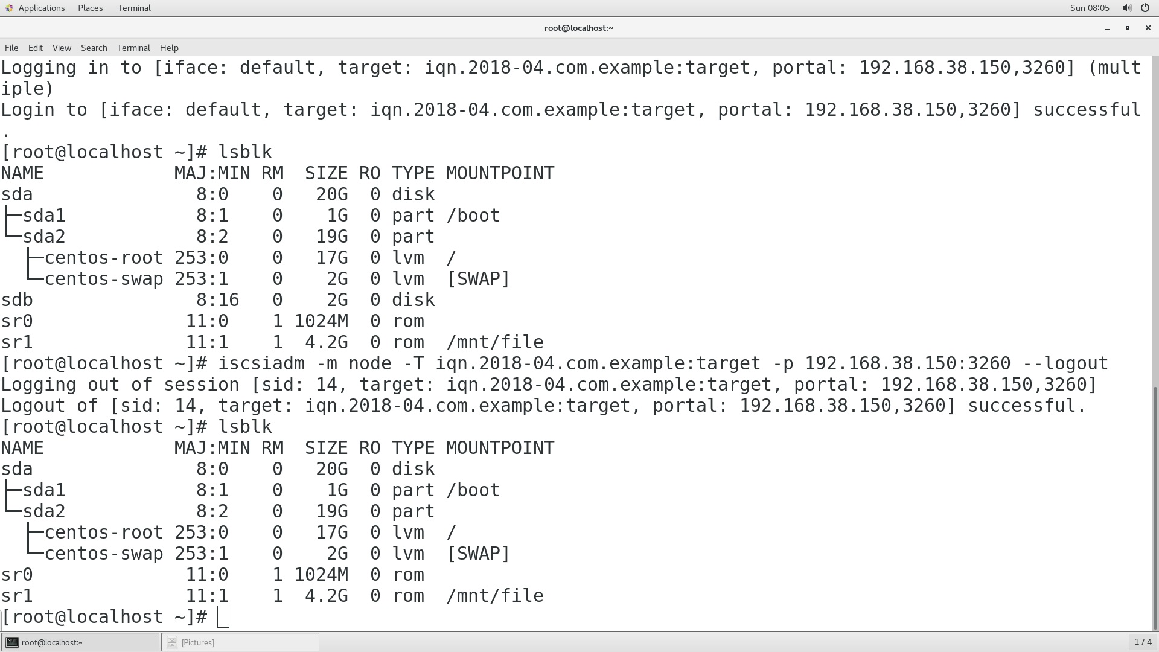

Client demand with server for more disk then server increase the LVM size.

1. **Client increase the Size of LVM by using the command**

* Check blkid id of the lvm partition which extension was formatted by:-

[root@localhost ~]# blkid

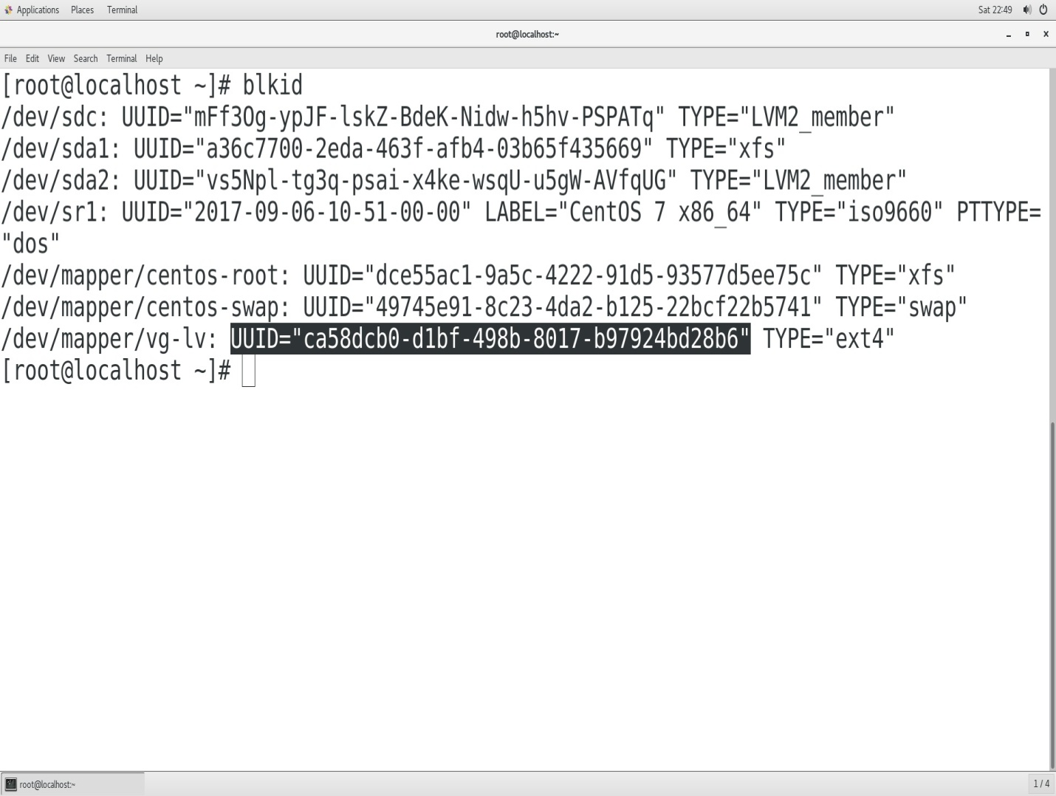

1. **Increase the size of the LVM block by using these command**

[root@localhost ~]# lvextend –L 3G /dev/vg/lv

[root@localhost ~]# systemctl restart target

1. **Restart the iscsi service**

[root@localhost ~]# systemctl restart iscsi

[root@localhost ~]# systemctl restart iscsid

1. **Client discover the IQN and login with server IQN and IP address**

[root@localhost ~]# iscsisadm –m discovery –t sendtargets –p 192.168.38.150

[root@localhost~]# iscsiadm –m node –T iqn.2018-04.com.example:target –p 192.168.38.150:3260 –login

Now the lvm size is increases

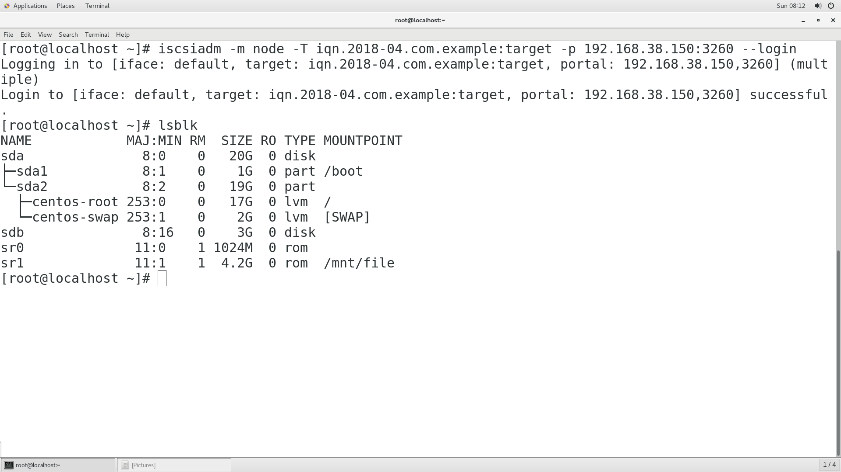

1. **Client securely logout the seesion by using these command**

[root@localhost ~]# iscsiadm –m node –T iqn.2018-04.com.target –p 192.168.38.150:3260 –logout

**Linux to window server configuration**

**Steps:-**

1. **Linux server configure iscsi server at own side**

[root@localhost ~]# targetlcli

* Ls



1. **Open iscsi initiator from window**

Put the client iqn at the configuration block

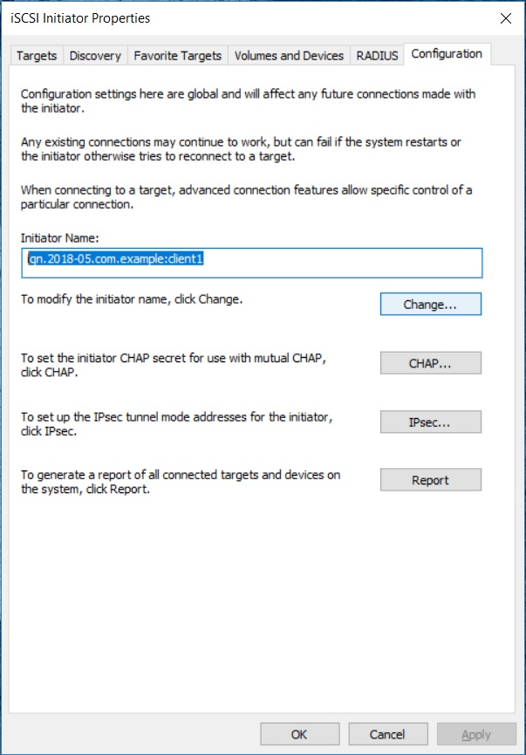

1. **In discovery option discover the target portal box with server IP address**

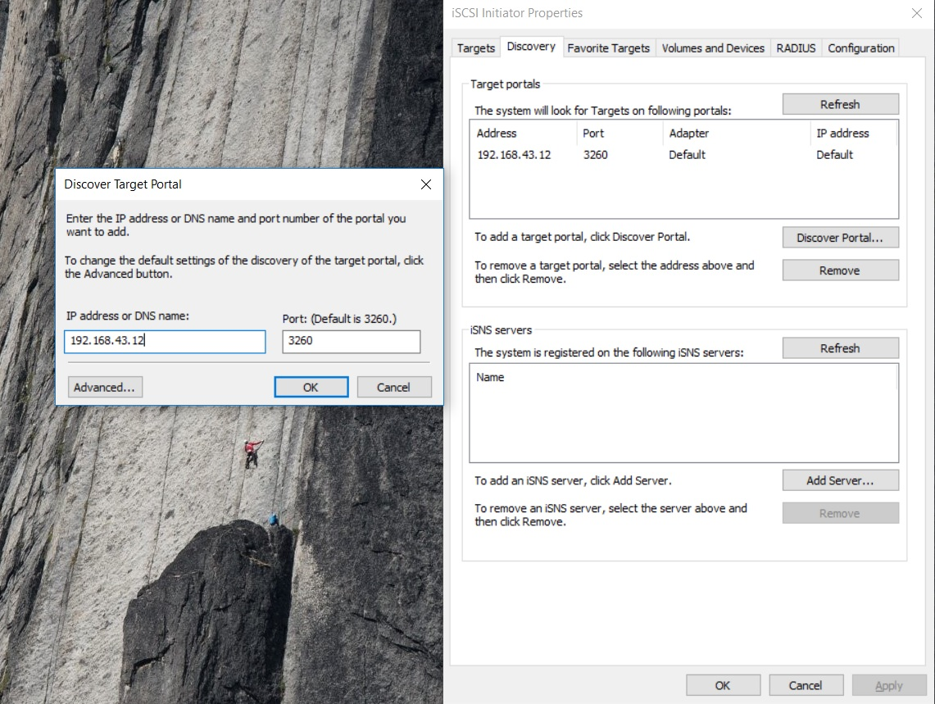

1. **After the target portal discover in target option connect with the target IQN**

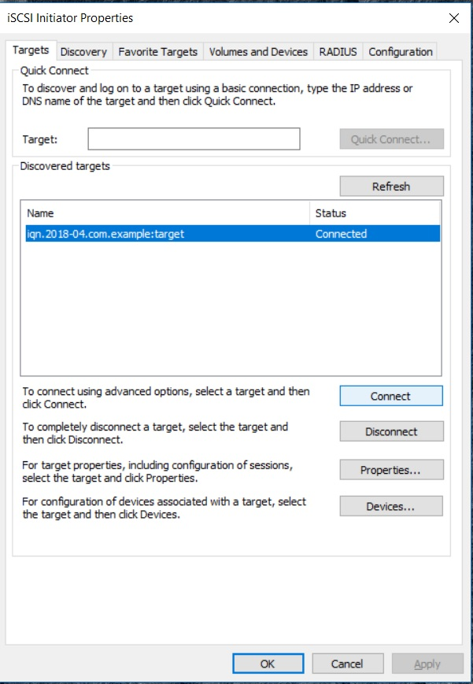

1. **Right click on my computer and select the mange option it will appear like as:-**

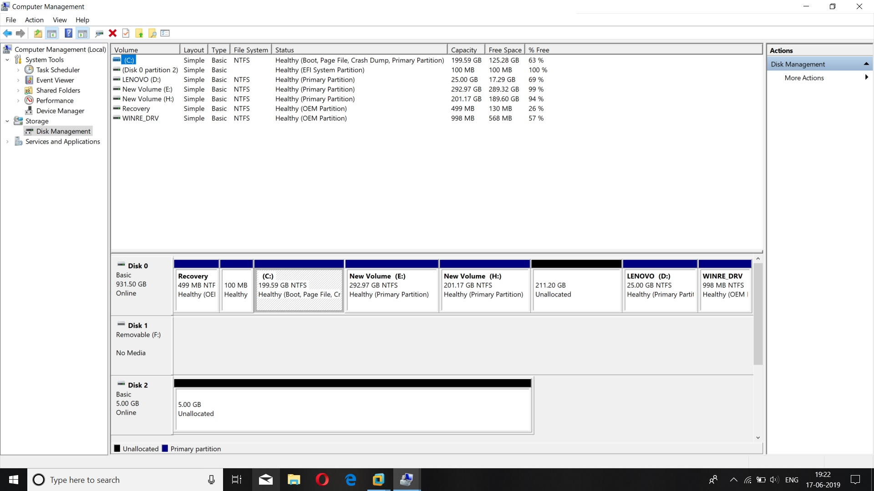

1. **Click on the unallocated disk which receive from server and create new simple volume with right click**

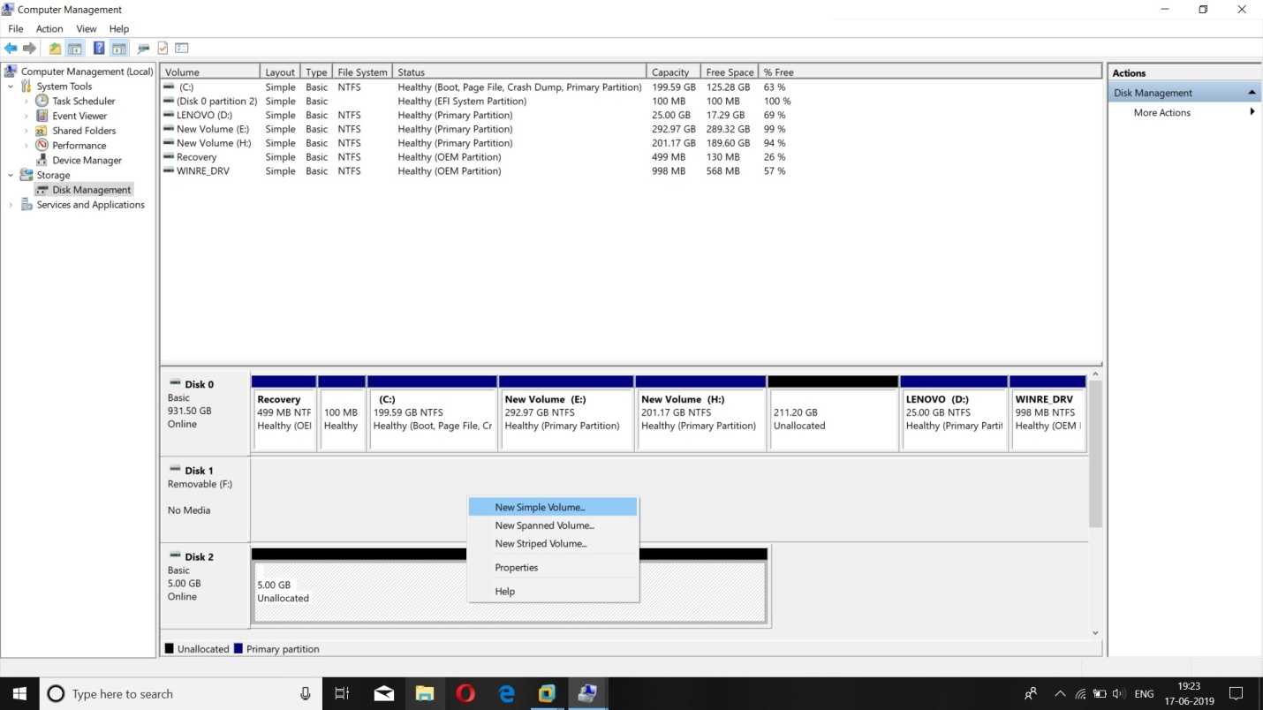

1. **Follow the new partition process**

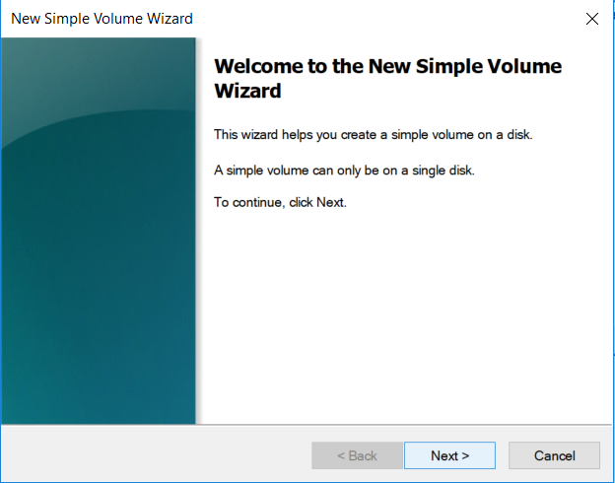

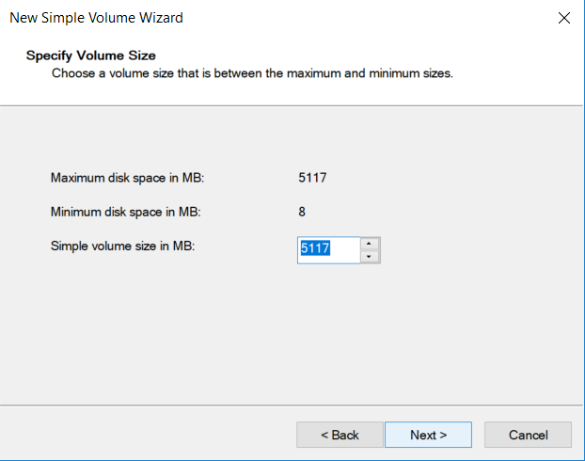

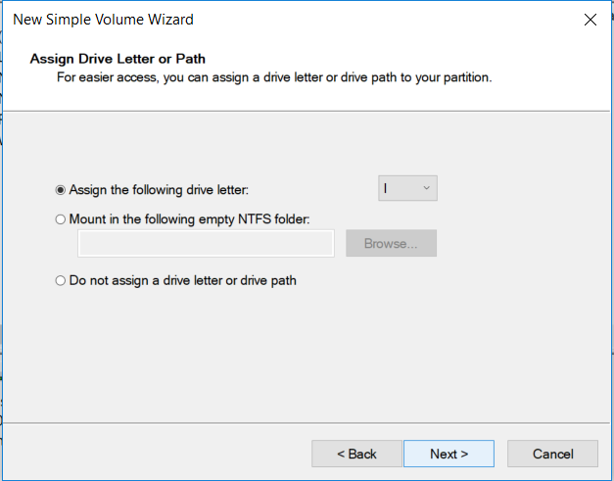

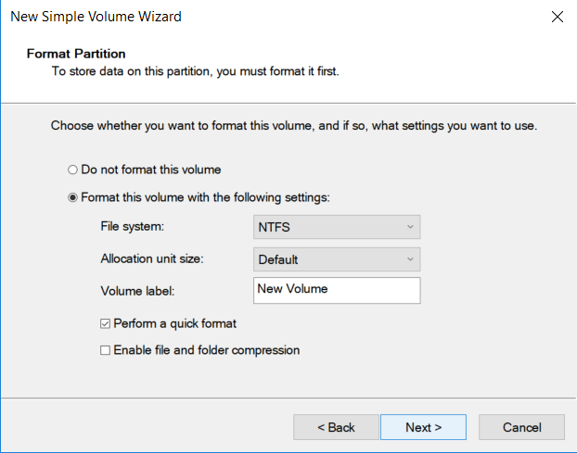

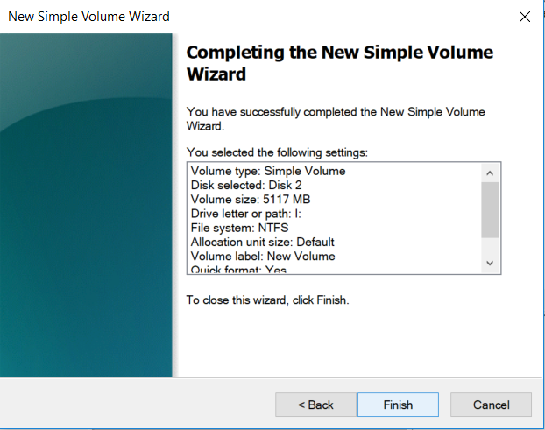

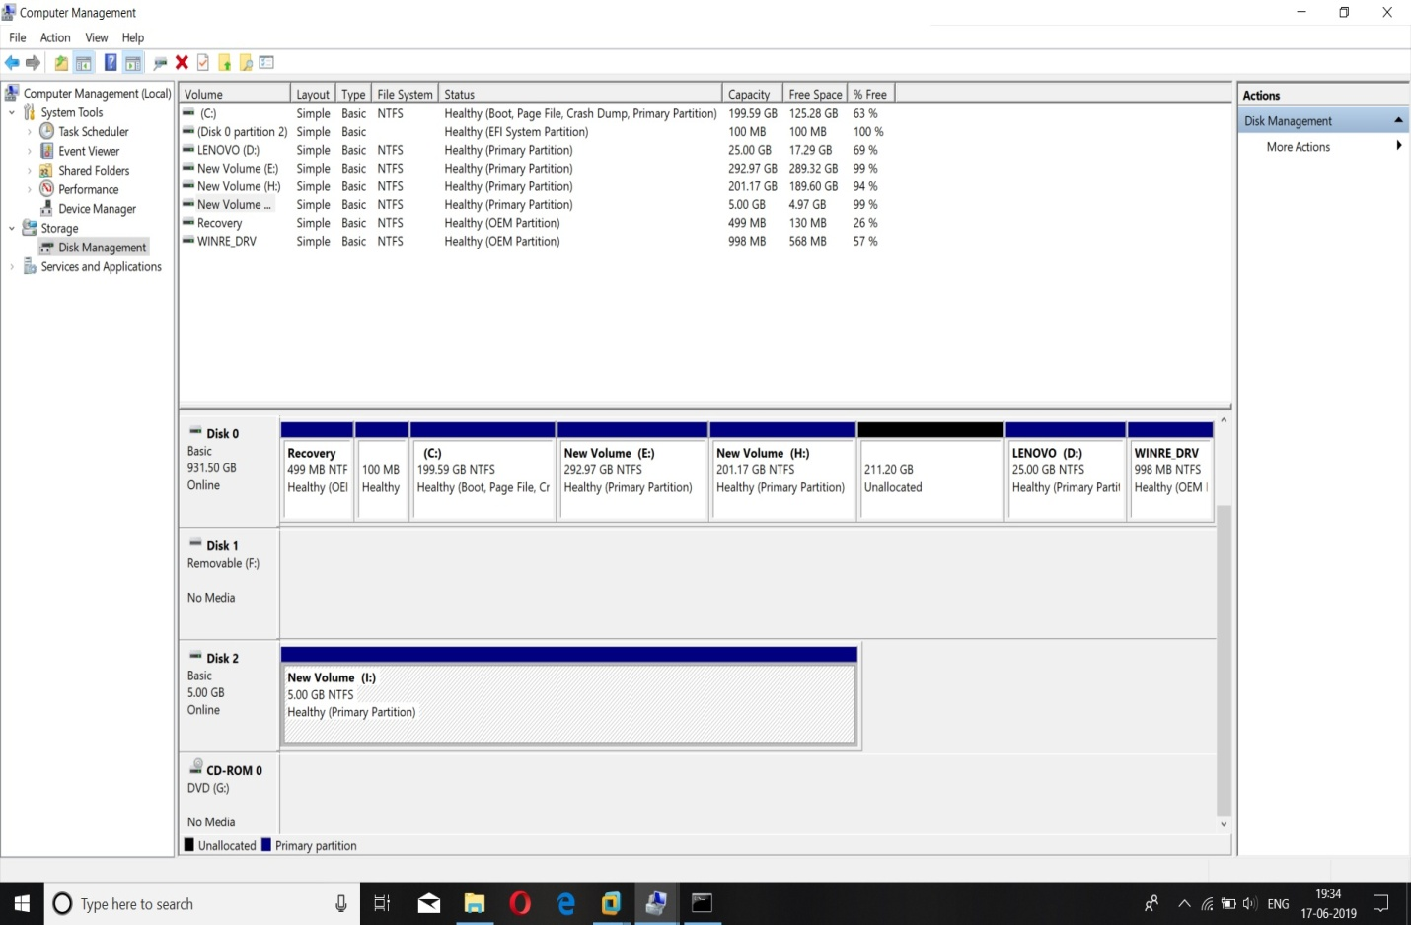

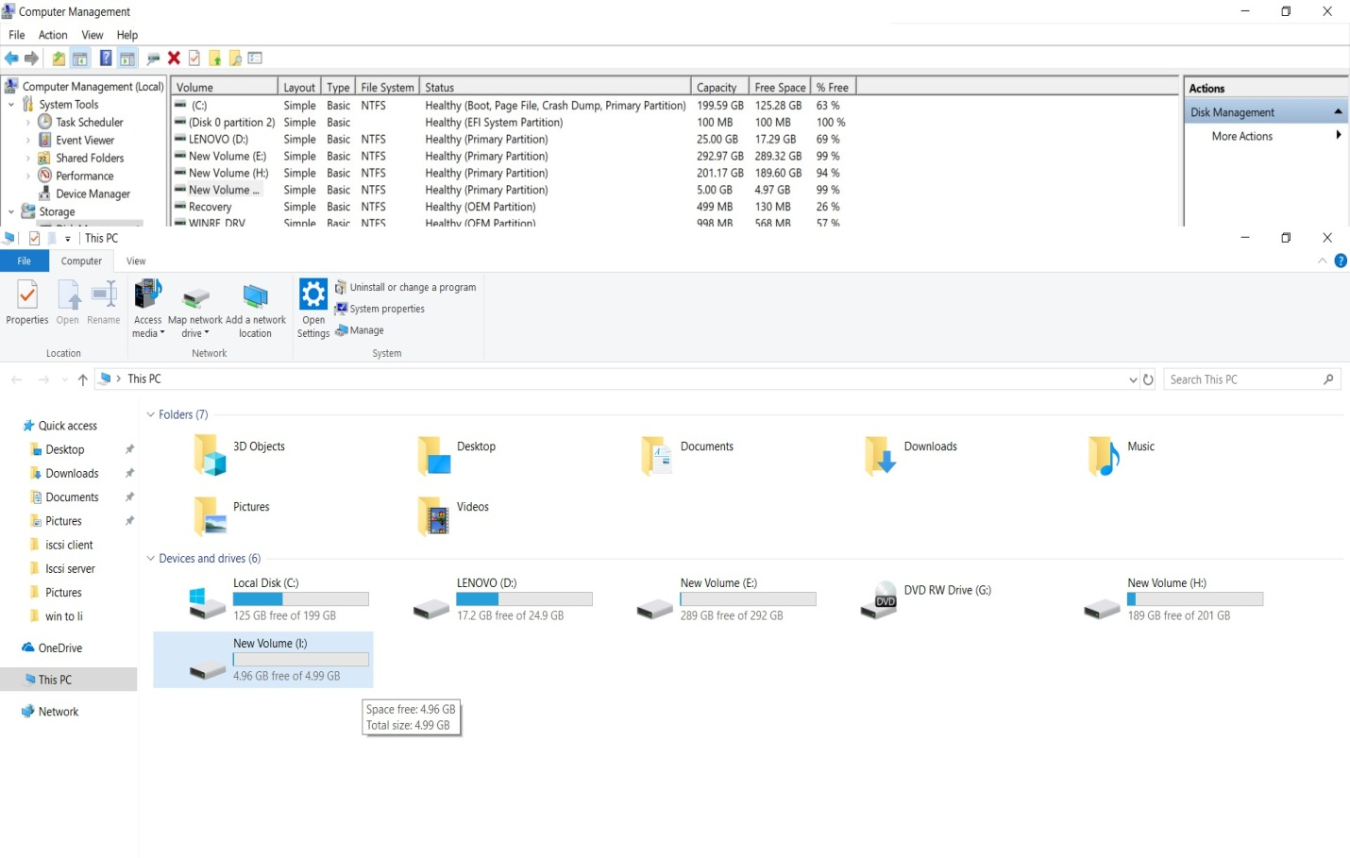

* **Conclusion**
* **iSCSI concept**
* Describe the history of the SCSI protocol and adaptaion for use over networks.
* Describe block storage cabling topologies.
* Define iSCSI components and terms.
* **Providing iSCSI Targets**
* Identify the steps to install and configure an iSCSI target server.
* Describe the components for building a single iSCSI target.
* Describe the components for providing access security for each iSCSI target.
* **Accessing iSCSI storage**
* Describe the installation and configuration of an iSCSI initiator.
* Outline the steps to access and login to an iSCSI LUN.
* Describe how iSCSI persistent connections are implemented.